**EDINBURGH COGNITIVE AND BEHAVIOURAL ALS SCREEN - ECAS   
Tele-Assessment Instruction Sheet**

1. **Set up the room – make sure the room set up is:**

  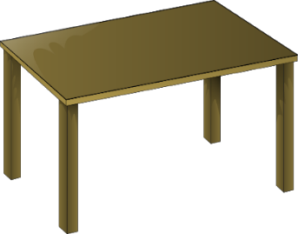 

Quiet Well lit Has a table You won’t be disturbed  
 **You will need to concentrate for 30 minutes without distractions**

1. **Set up your device – make sure the device has:**

C:\Users\sarah.adam\AppData\Local\Microsoft\Windows\INetCache\IE\P6CL4O1C\red-31226_960_720[1].png   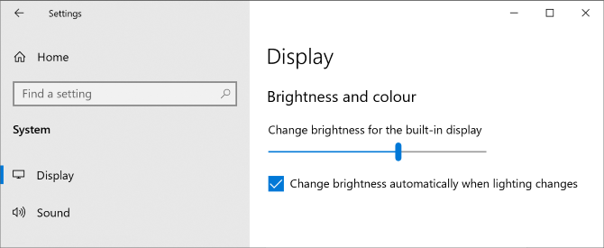

A screen of at least 9“ No reflections The brightness turned up

  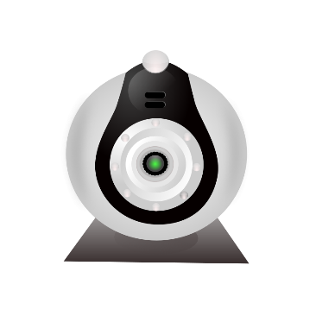

Google Chrome A webcam, microphone and speaker Notifications turned off  
 (these are often inbuilt into the device already)

1. **Wifi and connectivity – make sure the device is:**



Connected to WiFi Plugged in and charging  
 with a reliable connection

1. **Positioning – make sure that you:**

C:\Users\sarah.adam\AppData\Local\Microsoft\Windows\INetCache\IE\P6CL4O1C\red-31226_960_720[1].png**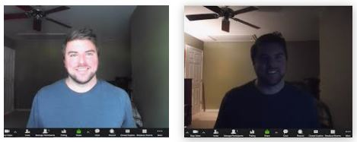**

Are visible on the screen and that it is not back-lit

**In case of disconnection:**

* Please reload the link provided
* The clinician/researcher will call you on your telephone number