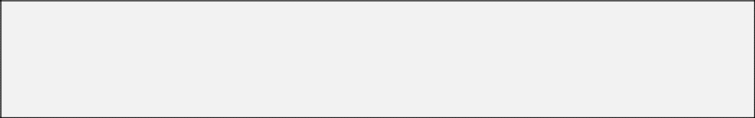**EDINBURGH COGNITIVE AND BEHAVIOURAL ALS SCREEN (ECAS)   
Booklet for Written Responses - A**

**Name the pictures**

1. **………………………………………………………...…..**
2. **…………..………………………………………..………**
3. **………………………..…………………………...………**
4. **……………………………………..……………..…….....**
5. **.………………………………………………..............….**
6. **……………………………………………………............**
7. **……………………………………………..…………...…**
8. **………………………………………………………….…**

**Can you choose the correct picture?**

1. **..………………………………………………………...…**
2. **…………………………………………………………….**
3. **………………………………………………………….…**
4. **………………………………………………………….…**
5. **………………………………………………………….…**
6. **………………………………………………………….…**
7. **………………………………………………………….…**
8. **…………………………………………………………….**

**What can you remember from the story?**

**Spell some words**

1. **………………………………………………………….…**
2. **………………………………………………………….…**
3. **…………………………………………………………….**
4. **…………………………………………………………….**
5. **…………………………………………………………….**
6. **…………………………………………………………….**
7. **………………………………………………………….…**
8. **…………………………………………………………….**
9. **…………………………………………………………….**
10. **………………………………………………………....**
11. **…………………………………….............................**
12. **…………………………………….............................**

**Write as many words as you can beginning with the given letter**

**When asked, copy the words you have written as fast as you can**

**Write the numbers in the reverse order**

**1. .............................. 7. ..............................**

**2. .............................. 8. ..............................**

**3. .............................. 9. ..............................**

**4. .............................. 10. ..............................**

**5. .............................. 11. ..............................**

**6. .............................. 12. ..............................**

**Alternate between numbers and letters**

**Use ‘Booklet for Written Responses – B’ for this task**

**Write as many words as you can beginning with the given letter - words must be 4 letters long only**

**When asked, copy the words you have written as fast as you can**

**How many dots are in each box?**

1. **……………….…….. 3. ………..……..……..**
2. **…..……………….… 4. ………..…………....**

**How many cubes are in each structure?**

1. **………………..….… 3. ………..……..……..**

**2. ………………..….… 4. ……..……..………..   
  
  
Which number corresponds to the dot?**

1. **……………….…….. 3. ……..………..……..**

**2. ………..………….… 4. …...………..………..**

**Write a word that finishes the sentence**

1. **…………………………………………………………….**
2. **…………………………………………………………….**

**This time the word you give should not make sense in the context of the sentence**

1. **…………………………………………………………….**
2. **…………………………………………………………….**
3. **…………………………………………………………….**
4. **…………………………………………………………….**
5. **…………………………………………………………….**
6. **…………………………………………………………….**

**Choose the picture you like best**

1. **…………………………………………………**
2. **…………………………………………………**
3. **…………………………………………………**
4. **……………………………………………………**
5. **……………………………………………………**
6. **……………………………………………………**

**Choose the picture the face likes best**

1. **……………………………………………………**
2. **……………………………………………………**
3. **……………………………………………………**
4. **……………………………………………………**
5. **……………………………………………………**
6. **……………………………………………………**

**What can you remember from the story?**

**What else can you remember from the story?**

**Circle your answer in response to the questions**

1. True False
2. True False
3. True False
4. True False
5. True False
6. True False
7. True False
8. True False